Introduction of International Business

Thank you for your interest in the international business of Kyochon F&B.

1.The basic international business model: Master Franchise
The Master Franchise has exclusive right to represent Kyochon in the designated area. Master Franchisee must have F&B experience and its own management team to develop Kyochon business . Unfortunately, we do not offer single unit franchisee outside of Korea.

2. Requirements of Master Franchise applicants
- Local registered corporation  - At least 3 years business experience in F&B industry, and/or franchise industry  - Comprehensive understanding of local market | - Sufficient financial ability to expand Kyochon business  - Experienced in store development
  - The above requirements are conditions of Kyochon’s Master franchise partner. The final decision will be made through an internal review considering the comprehensive aspects.

3. Benefits of Mater Franchise Partner
- Exclusive right to use Kyochon brand in the designated area
- Exclusive right to use Kyochon’s various sauces and powders & develop localized menu
- Regular support from the HQ (Providing cooking and service training & Store operation support)
- Provide Kyochon’s unique interior & exterior design and all other drawing design support

4. Applicant process
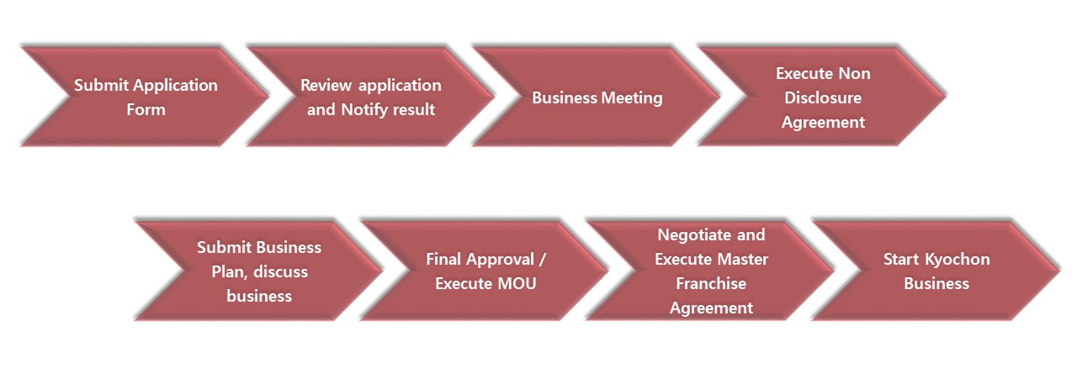
- The terms and conditions are negotiable. The specific details will be discussed after the meeting process.

For the Master Franchise business, please be aware of the above information and submit the [Application Form] to: overseas@kyochon.com

Master Franchise Application

1. Personal information
Name
Contact
Title
Email
Desired Territory

2. Company information
Name of company
Address
Website
Type of business
Type of organization  (Legal status) | □ Limited company □ Corporation  □ Joint Venture (Investment rate : %) □ Other (_____________)
Year established
Name of brands
Number of employees
Subsidiary / Affiliate | □ YES (Name of Subsidiary/Affiliates : )  □ NO

3. Financial information (Based on last year standard)
Assets | USD ( Year) (Please state the currency used)
Equity | USD ( Year)
Liabilities | USD ( Year)
Gross sales | USD ( Year)
Operating profits (%) | USD / Rate % ( Year)
Net Profits | USD ( Year)
  - Provide us, if any, with detailed information regarding the financial information that will help us understand your business.

4. Motivation for Business Application
▶How did you get to know Kyochon chicken?
□ Visit store (location: ) □ Website/SNS □ Introduced by Aquaintace
□ Other (Explain) _______________________
▶Describe in detail the motive for wanting to carry out Kyochon overseas business.
_________________________________________________________________________________________________________________________________________________________________________________________________________________________________________________________

5. F&B experience
▶Do you have any restaurant and/or F&B management experience? □ YES □ NO
▶If “YES”, please describe the details as follows :
* Name of Brand:
* Type of contract: □ Franchise store □ Franchise direct management store
□ Personal brand established □ etc ( )
* Operation period:
* Other:

6. Local Market understanding
▶Is the representative or applicant of the desired country nationality? □ YES □ NO
▶Is the representative or applicant residing in the desired country? □ YES □ NO
▶Please describe the details about your Local Market understanding :
____________________________________________________________________________________
____________________________________________________________________________________
____________________________________________________________________________________

7. Kyochon Business Plan & Investment information
▶Please indicate in order of preferences, the Territory where you wish to develop stores and describe how you would run Kyochon stores.
* Country ( ) City/Region ( )
* Number of stores ( )

▶ How much capital do you have available to invest in Kyochon business?
▶ How long will it take to raise capital? ( month(s))
▶Do you have any business partners or investors involved? □ YES □ NO
* If “YES”, please provide details:
Type | Information with business partners or investors
    - Partner □ Investor

▶Please provide other information that we can refer to:
____________________________________________________________________________________
____________________________________________________________________________________

8. Additional Documents (Attachments)
- (Required) Business License (affidavit)
- (Required) Company profile
- (Others)

I hereby confirm that the above information is true and complete to the best of my knowledge. I acknowledge that any false statement on this application shall be considered sufficient cause to deny any further consideration or cause revocation of any signed agreement with Kyochon F&B.

Applicant : | ___________________ (signature)
Date : | __________________

All information will be kept strictly confidential and used for the purpose of reviewing only. It may not be processed if some information is not properly responded, or supplements are missing. And you understand that omission or misrepresentation of information in this form may result in disapproval.

[Personal Information Collection and Usage Agreement]

Kyochon F&B collects personal information according to the “Personal Information Protection Act” of the details below. Please carefully read the information below and make a decision whether or not you agree with the collection and usage of personal information.

- Purpose of collection and usage of personal information
- Management of the applicant
- Personal Information Collected
- Name (Korean/English), Company, Title, Contact, E-mail, Year established, Address, Business license, Financial information, F&B experience, Nationality and etc which written in the application and Attachments.
- Possession Period
- 3 years
- Right to refuse consent
- You, the applicant have the right to refuse consent for the collection and usage of personal information, and if you refuse consent, there may be restrictions or disadvantages in accepting and reviewing the business application

I agree to the collection and usage of my personal information as above. | Agree □ Disagree □

Date : | _______/_______/_______
Name : | _____________________ (signature)

